We have employee_details and employee_expenses files. Use local mode while running Pig and

write Pig Latin script to get below results:

https://github.com/prateekATacadgild/DatasetsForCognizant/blob/master/employee_details.t

xt

https://github.com/prateekATacadgild/DatasetsForCognizant/blob/master/employee_expense

s.txt

(a) Top 5 employees (employee id and employee name) with highest rating. (In case two

employees have same rating, employee with name coming first in dictionary should get

preference)

**Answers**

1. Emp_dt = LOAD ‘/home/acadgild/emp_dt.txt’ USING PigStorage(‘,’) as (id:int,name:chararray,salary:int,rating:int);

emp_ord = order emp_dt by rating desc, name asc;

lim = limit emp_order 5;

emp = foreach lim generate id, name;

dump emp;

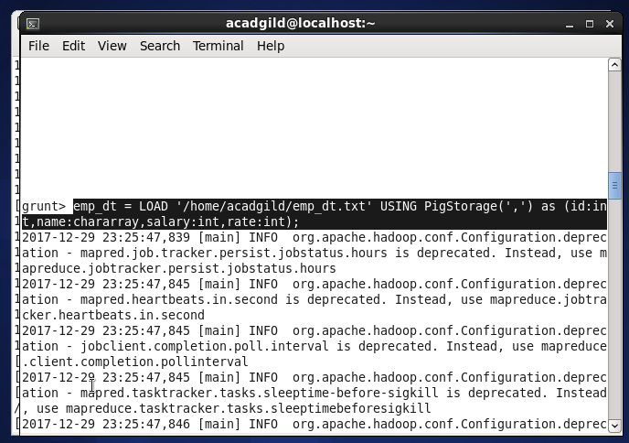

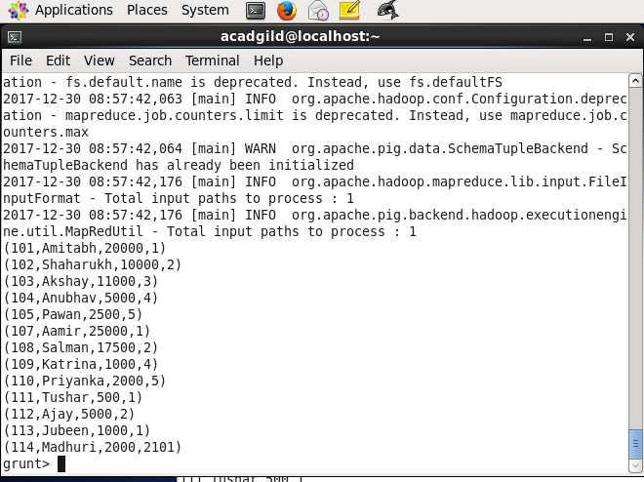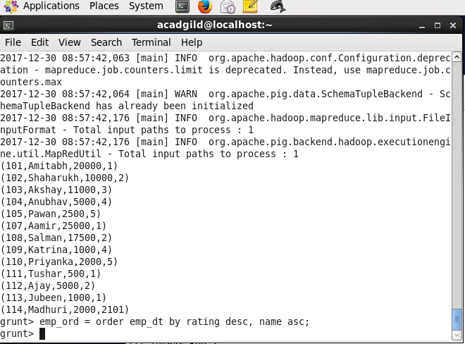

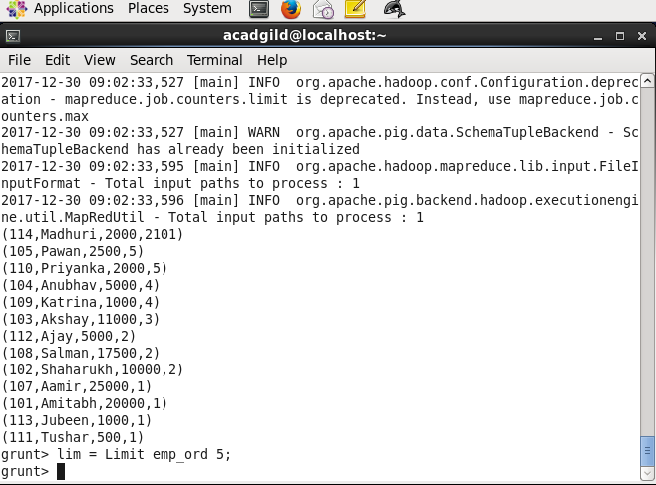

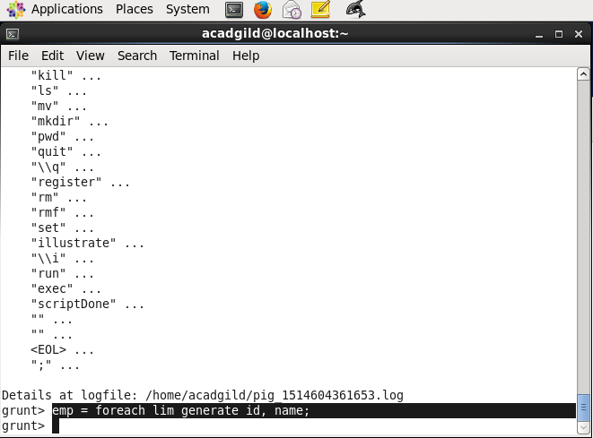

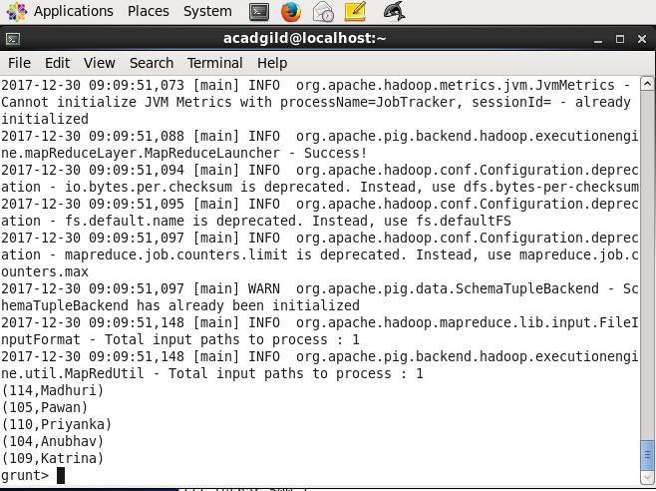

(b) Top 3 employees (employee id and employee name) with highest salary, whose employee id

is an odd number. (In case two employees have same salary, employee with name coming first

in dictionary should get preference)

Answer :

Emp_det = LOAD ‘/home/acadgild/emp_dt.txt’ USING PigStorage(‘,’) as (id:int,name:chararray,salary:int,rating:int);

emp_fil = filter emp_det by (id % 2) != 0;

emp1_order = order emp_fil by salary desc;

lim1 = limit emp1_order 3;

emp1 = foreach lim1 generate id, name;

dump emp1;



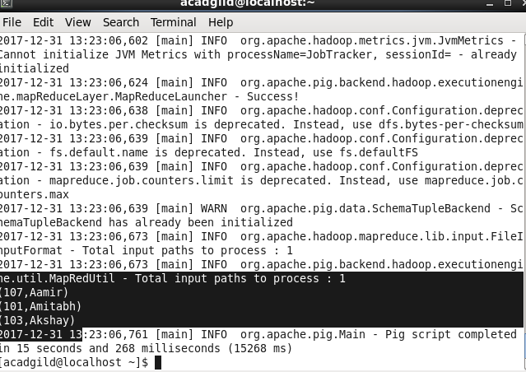

(c) Employee (employee id and employee name) with maximum expense (In case two

employees have same expense, employee with name coming first in dictionary should get

preference)

Answer :

Emp_det = LOAD ‘/home/acadgild/emp_dt.txt’ USING PigStorage(‘,’) as (id:int,name:chararray,salary:int,rating:int);

Emp_exp = LOAD ‘/home/acadgild/emp_exp.txt’ USING PigStorage(‘,’) as (id:int, expenses:int);

emp_join1 = join emp_det by id, emp_exp by id;

emp2_order = order emp_join1 by expenses desc, name asc;

lim2 = limit emp2_order 1;

emp2 = foreach lim2 generate $0,$1;

dump emp2;

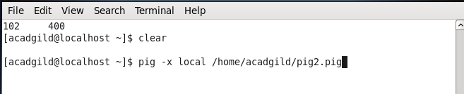

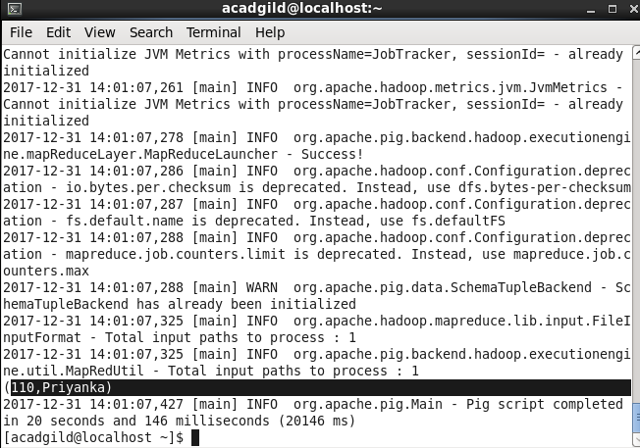

(d) List of employees (employee id and employee name) having entries in employee_expenses

file.

Emp_det = LOAD ‘/home/acadgild/emp_dt.txt’ USING PigStorage(‘,’) as (id:int,name:chararray,salary:int,rating:int);

Emp_exp = LOAD ‘/home/acadgild/emp_exp.txt’ USING PigStorage(‘,’) as (id:int, expenses:int);

emp_join2 = join emp_det by id, emp_exp by id;

emp3 = foreach emp_join2 generate $0,$1;

distnct = distinct emp3;

dump distnct;



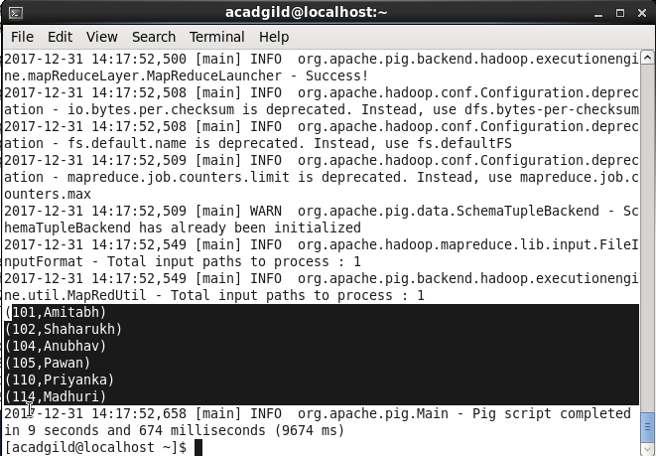

(e) List of employees (employee id and employee name) having no entry in employee_expenses

file.

emp_join3 = join emp_det by id left outer, emp_exp by id;

emp4_fil = filter emp_join3 by $4 is null and $5 is null;

emp4 = foreach emp4_fil generate $0,$1;

distnct1 = distinct emp4;

dump distnct1;

